# AMST number explicit Tesla count

# Use the instructions

**I. Overview**

Digital explicit Tesla meter is a portable, multi-functional magnetic field measuring instrument, equipped with high sensitivity, low drift Hall sensor, and applied advanced digital signal processing technology for measuring the surface magnetic field of permanent magnetic materials, residual magnetic machine of mechanical parts, magnetic picker or iron remover, etc.It can be used as a basic magnetic parametric measurement instrument to magnetic material manufacturers and application units, machinery manufacturing enterprises, and scientific research units of colleges and universities.

1. **Functional characteristics**

2.1. Three accuracy levels: 1,2 and 5 are suitable for different magnetic field measurement occasions.

2.2. Two magnetic field units: mT(ms), Gs(Gauss), 1mT=10Gs.

2.3. Measurement range: 0-2,400 mT (24,000 G s).

2.4. With the function of automatic measuring range switching, one-key zero clearance, and maximum value keeping.

2.5. Display screen backlight, 5-minute automatic shutdown function.

2.6. Low power consumption, light and portable.

2.7. Multiple Hall probes are available.

**III. Technical parameters**

|  |  |  |
| --- | --- | --- |
| Scales | 200mT（2000Gs） | 2000mT（20000Gs） |
| Fractional values | 0.01mT（0.1G） | 0.1mT（1G） |
| Accuracy (Level 1) | ±1.0% | |
| Accuracy (Level 2) | ±2.0% | |
| Accuracy (Level 5) | ±2.0%（0...1000mT），±5.0%（1000mT...2400mT） | |
| Power supply | 19V battery | |
| Work environment | 0℃~50℃, 20%~85%R·H, is not exposed | |
| Storage environment | -20℃~70℃, <85%R·H, is not exposed | |
| Instrument size | 160mm×75mm×34mm | |
| Instrument weight | About 260 g (including battery and wire) | |
| Hall probe | The radial Hall probe is standard, and the wire is about 1 m long | |

**IV. Appearance structure**

4.1. Appearance

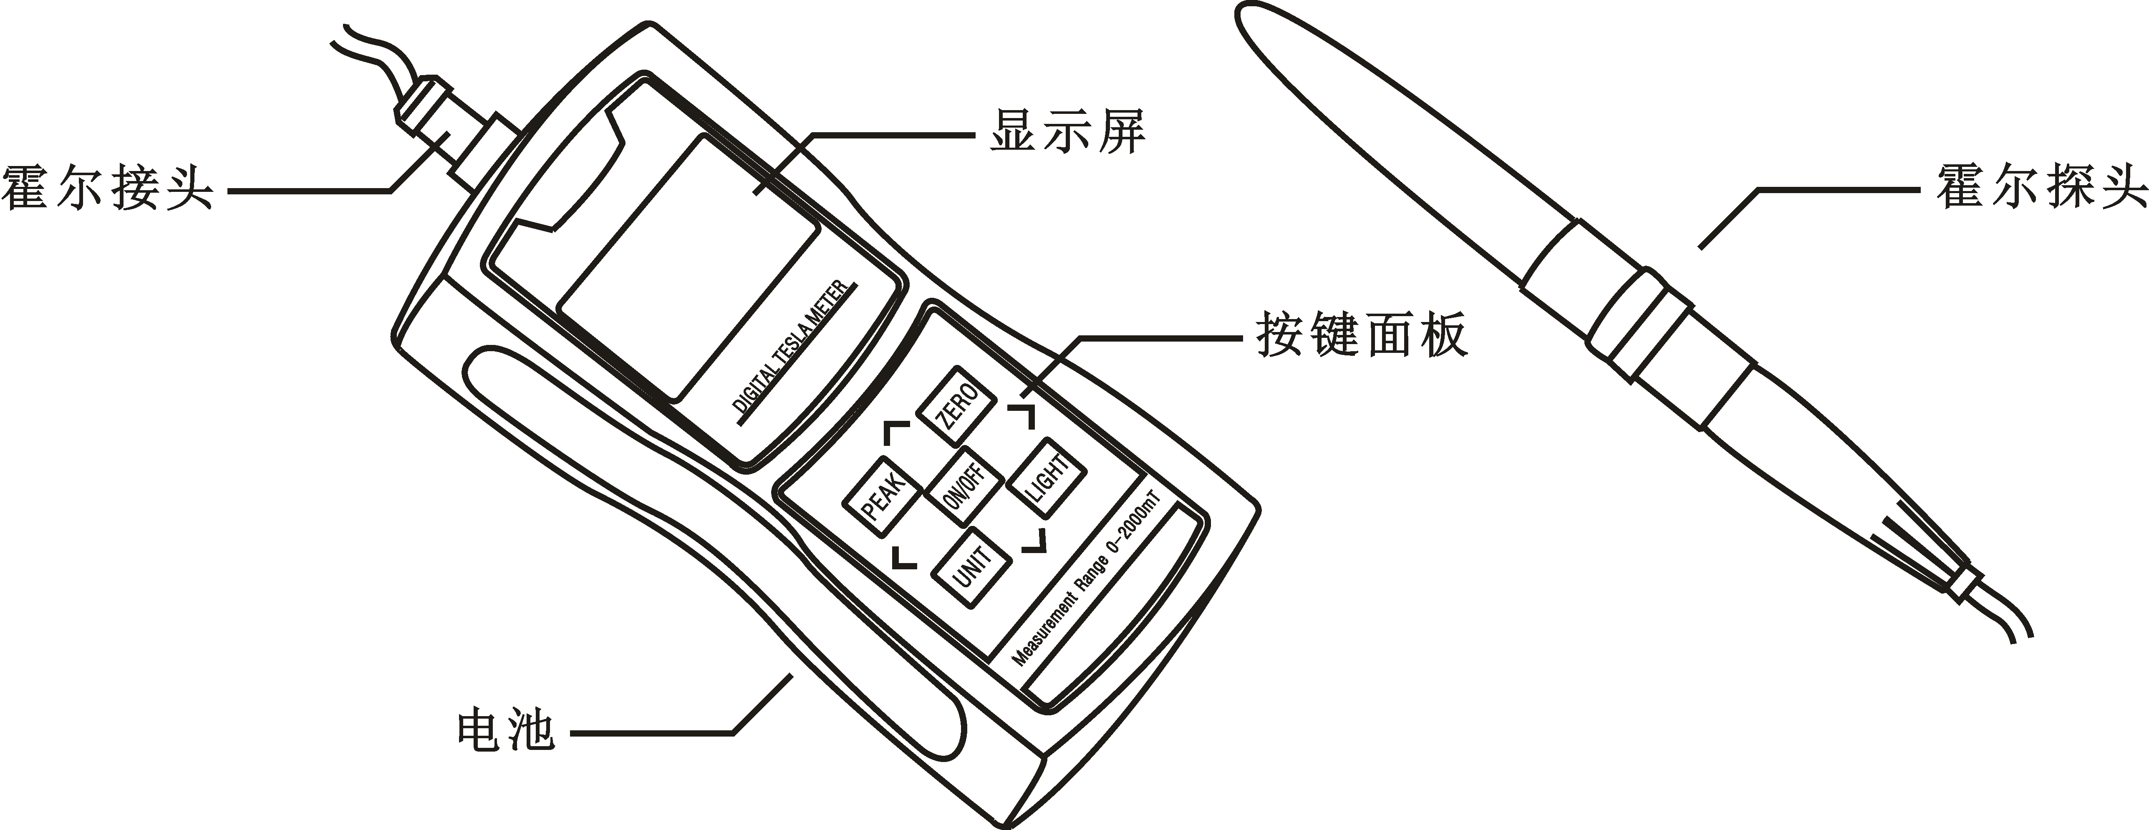

4.2. Display screen

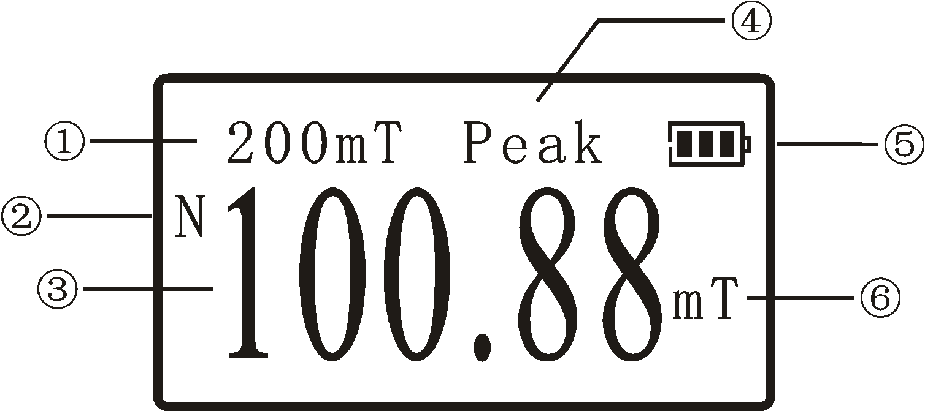

① range prompt: when the measured magnetic field is less than 200mT, the default range is 200mT; when over 200mT, the range automatically switches to 2000mT.

② magnetic field polarity: When the magnetic field direction is through the front of the Hall sensor, the screen shows "N"; When the magnetic field direction is through the back of the Hall sensor, the screen shows "S".

③ measurement: The Hall sensor displays the measured magnetic field in digital form.

④ peak mode: When the screen shows "Peak" is the peak mode, the magnetic field value shows the maximum value measured for a period of time and remains unchanged.

⑤ battery power: Display the current battery power.

⑥ units: Display the current magnetic field units (mT/ mter, Gs/ Gaussian).

4.3. Key panel

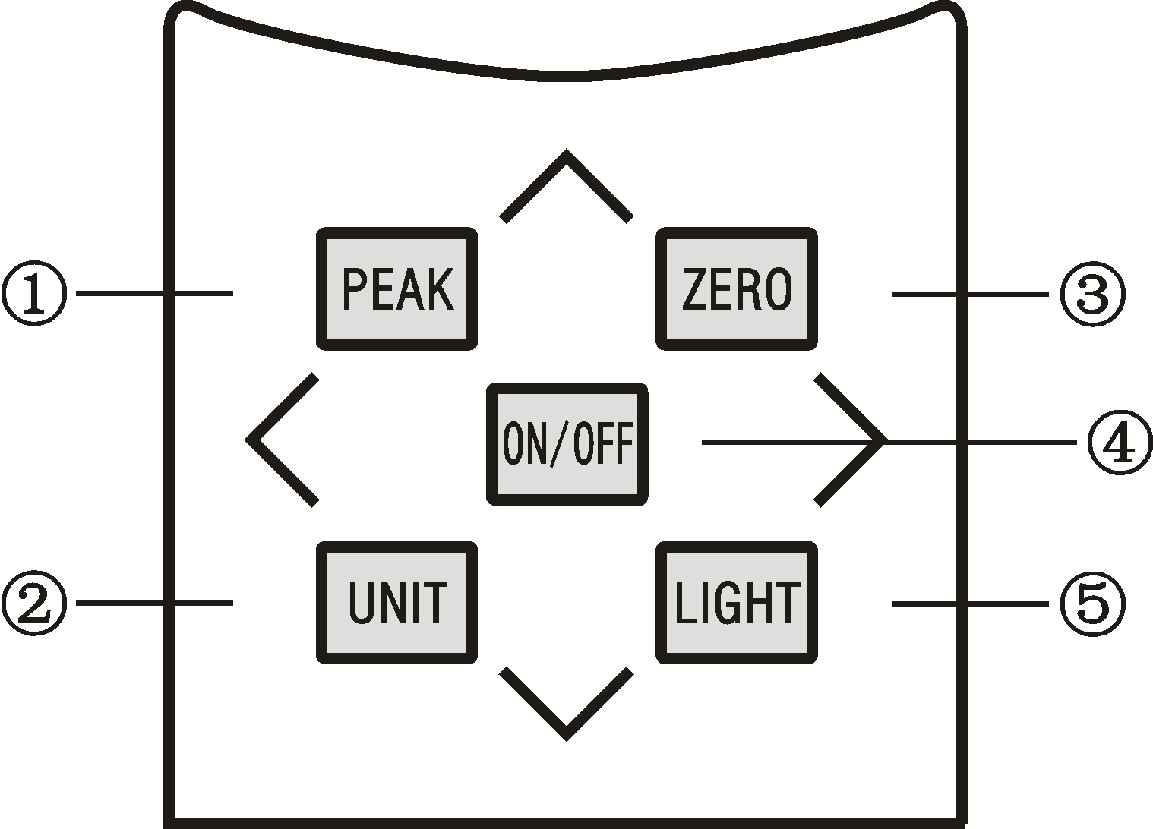

① mode PEAK key: one-button free switch between real-time mode and peak mode.

② unit UNIT key: one key free switch magnetic field unit.

③ zero ZERO key: zero key, zero value without magnetic field.

④ Backlight LIGHT key: Backlight on or off.

⑤ on / off ON/OFF key: one button on or off.

1. **Hall probe**

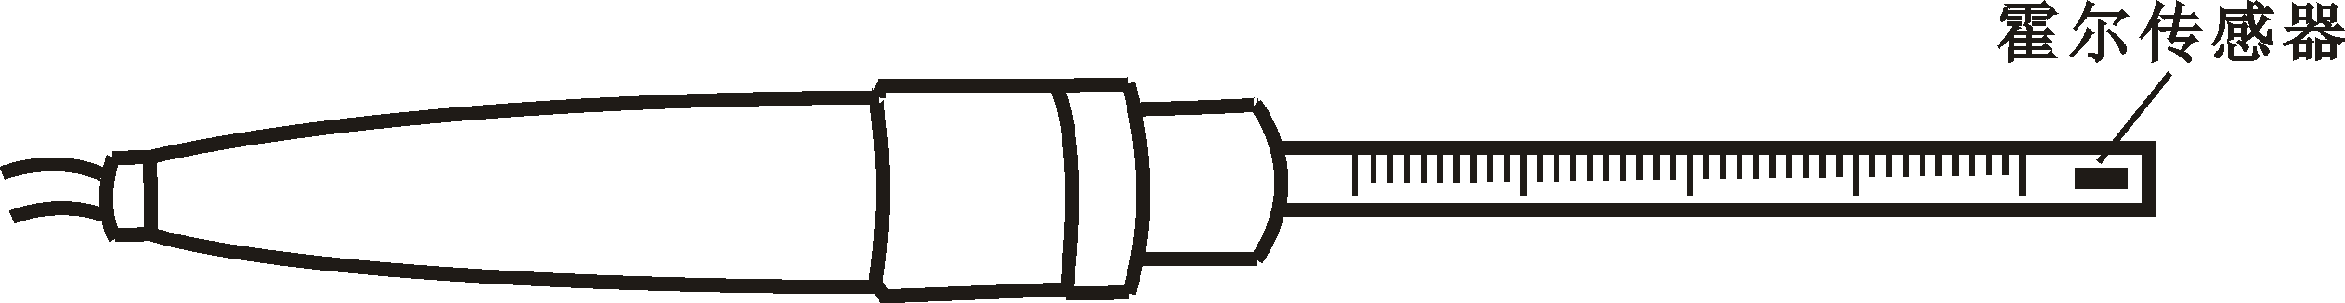

Radial Hall probe and sensors

5.1. The instrument is standard with a radial Hall probe.

5.2. If the permanent magnet is measured, the Hall sensor should be as close to the sample surface as far as possible, the farther away from the sample, the greater the magnetic field attenuation, the smaller the measured value.

5.3. When measuring the magnetic field, keep the Hall sensor always vertical to the magnetic field; if the magnetic field is not perpendicular to the sensor, the measurement error will be introduced.(The greater the deviation angle, the greater the error)

**VI. Basic measurement steps**

6.1. Connect the Hall probe to the host, and remove the plastic shield on the Hall probe.

6.2. Place the Hall probe in an environment without magnetic field and electromagnetic interference.

6.3. Press the power switch button to observe the screen to see if the display is 0.0mT.

6.4. If not 0.0mT,, press "zero ZERO" key for zero clearance.

6.5. Place the probe in the magnetic field to be tested, and read the magnetic induction strength value after the value is stabilized.

6.6. If you want to find the maximum value, press the "Mode PEAK" key to switch the peak mode to automatically maintain the maximum value.(Instrument startup default is real-time mode)

**VII. General fault analysis**

7.1. Unable to start on: please check whether there is a battery in the battery warehouse and whether the battery is insufficient. If there is no problem above, please contact the customer service of the manufacturer.

7.2. Automatic shutdown after a while: if the instrument has no operation for 5 minutes, it will be automatically shut off.If the shutdown is completed in less than 5 minutes, the battery is likely insufficient, please replace the new battery.

7.3. Digital irregular beating in the screen: please check whether the waterproof air probe interface is tight.

**VIII. Safety precautions**

8.1. Safe operation

8.1.1 The power supply of this instrument is 9V dry battery, do not use other types of battery, otherwise it may cause damage to the instrument.

8.1.2 After mounting the battery, turn off and tightening the battery cover.

8.1.3 If the battery leaks, do not load the battery into the battery compartment.

8.1.4 If the instrument is not used for a long time, please remove the battery to prevent the battery leakage from damaging the instrument.

8.2 Equipment maintenance

8.2.1 If an instrument fault is suspected, please stop using the instrument and repair it.

8.2.2 repairs only with qualified maintenance personnel and suitable tools and test equipment; observe the antistatic specification during maintenance.

8.2.3 During repair, please remove the battery first.

8.2.4 Please ensure that any troubleshooting affecting the performance of the instrument can be started again.

8.3. Use environment

8.3.1 To avoid explosion, do not use this instrument near deflagration gas, steam or dust.

8.3.2 Do not use or store it in a wet or strong electromagnetic interference environment, otherwise instrument damage or measurement data deviation may occur.

8.3.3 Please keep the product surface clean and dry.

8.3.4 Please refer to the "Technical parameters" item of the use instructions to use and store the instrument.

8.4. Correct operation

8.4.1 This instrument is an equipment for measuring permanent magnetic gauge or constant magnetic fields and shall not be used for other purposes.

Please follow the instructions in this manual during 8.4.2, otherwise measurement data may bias.

The 8.4.3 tested sample shall conform to the measurement range of the instrument, otherwise the measurement data deviation may occur.

8.4.4 Please select the correct function and set the test conditions according to the specific measurement requirements of the sample.

**IX. Random attachment**

|  |  |  |
| --- | --- | --- |
| Number number | Name | Number |
| 1 | The number of Tesla plans | One |
| 2 | Radial Hall probe | One |
| 3 | 9V Dry Battery | Section 1 |
| 4 | Instructions | 1 This |
| 5 | Warranty card | One |