Product Specifications
AK-RK02S
12V dual-channel learning code controller

V2.0

Contents
1. Overview 2
2. Product Characteristics 3
3. Operating Instructions 4
4. Electrical parameters 4
5. Wiring diagram 5
6. Notes 5
7. Edit History 6

Overview
The AK-RK02S dual-channel learning code controller uses a brand-name main control chip for programming, resulting in low standby power consumption. The controller features adjustable data bit pads, allowing customers to adjust the data bits according to their needs. It offers convenient single-button operation, multiple easy-to-switch working modes, and simple code pairing. It can be applied to lighting control, motor control, smart home control, and other control scenarios.
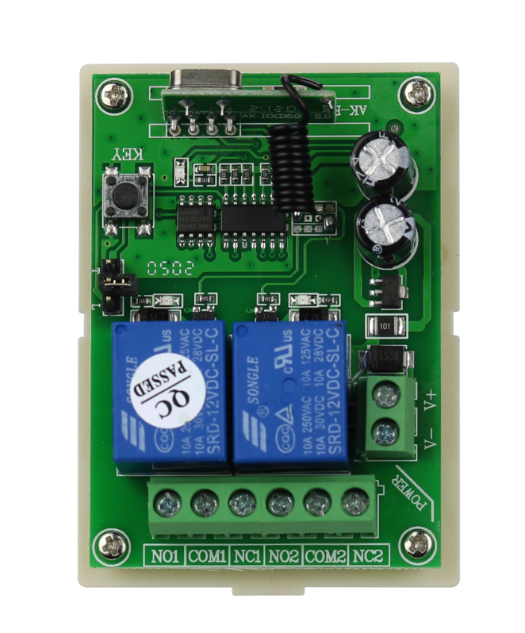

Product Characteristics
（1）Operating frequency：433.92MHz(Special frequencies can be customized according to customer requirements)；
（2）Power Solution：DC12V(Other power solutions can be customized)；
（3）Standby Current：7mA；
（4）Good selectivity and stray radiation suppression capability；
（5）Temperature range：-20-70℃（Can work normally even in harsh ambient temperatures）；
（6）Size：75.5*54.8*27.9mm（Including shell）；
（7）Weight：57g（Including shell）。

Operating Instructions
3.1 Learning code
Connect the controller to the power supply, press the controller's code learning button once to light up the indicator light, then press and hold the button on the remote control (the button on the remote control is the one that is used to learn the code). The controller's indicator light will flash to indicate that the code learning was successful.
3.2 Working Mode Switching Instructions
Momentary Mode: Disconnect the connector from the mode switch header on the controller; the operating mode is momentary mode.
Toggle Mode: Short-circuit mode switch headers 2 and 3 on the controller using the connector; the operating mode is toggle mode.
Latched Mode: Short-circuit mode switch headers 1 and 2 on the controller using the connector; the operating mode is latched mode.
3.3 Working mode description
Momentary mode: Pressing a coded button on the remote control engages the relay; releasing the button disengages the relay.
Toggle mode: Pressing a coded button on the remote control (e.g., button A) engages the relay; pressing button A again disengages the relay.
Latched mode: Pressing a coded button on the remote control (e.g., button B) engages the relay on the controller; pressing an uncoded button on the remote control (e.g., button C) disengages the relay on the controller.
3.4 Clear code operation
Press and hold the code learning button for 8 seconds until the controller indicator light turns from off to on, indicating that the code clearing was successful and all remote control codes were cleared.

Electrical parameters
No. | Parameter name | Parameter
1 | Rated voltage | DC12V
2 | standby current | 7mA
3 | Receive frequency | 433.92Mhz
4 | working methods | Momentary, Toggle, and Latched modes
5 | Output method | Terminal blocks
6 | Control distance | >100 meter
7 | Receiver sensitivity | -105dB
8 | Maximum load power | 1000W

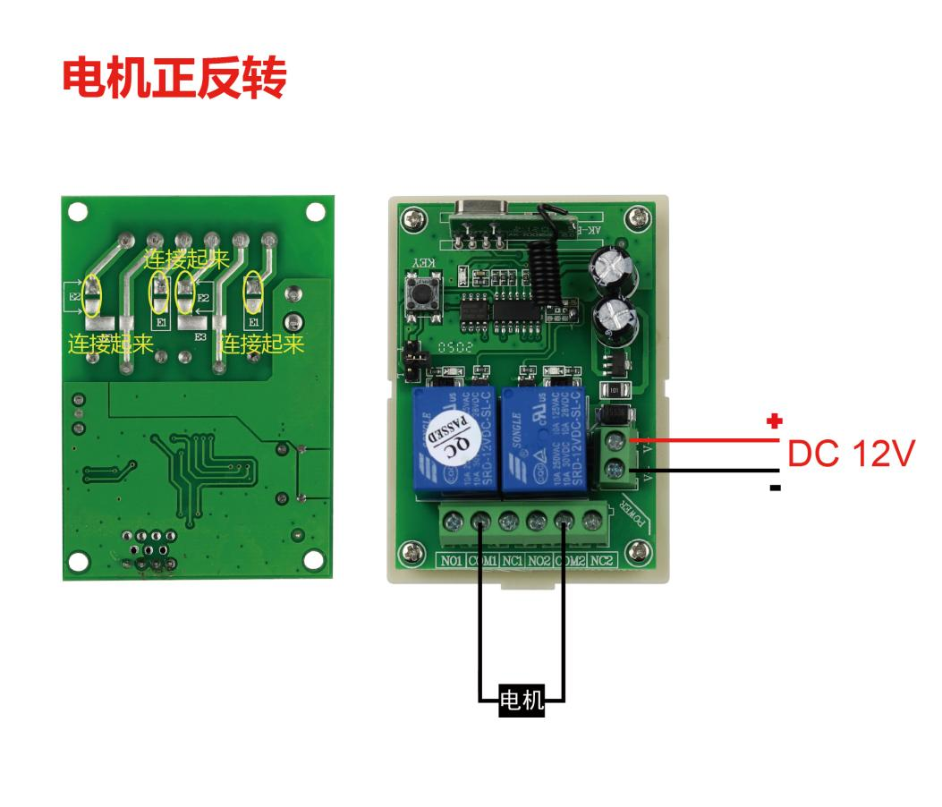
Wiring diagram
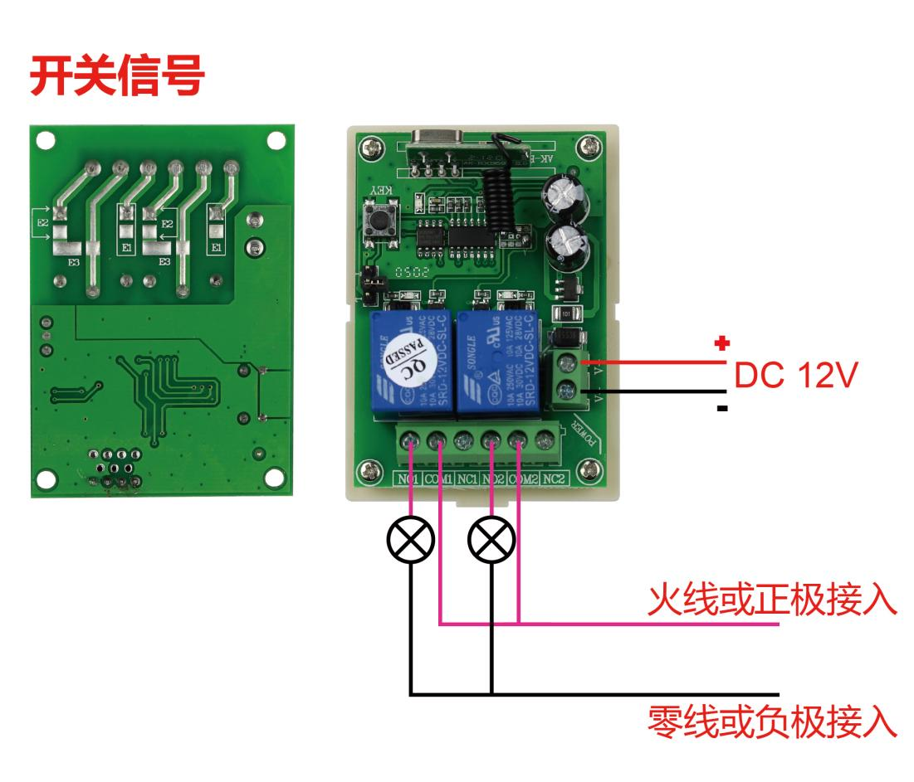

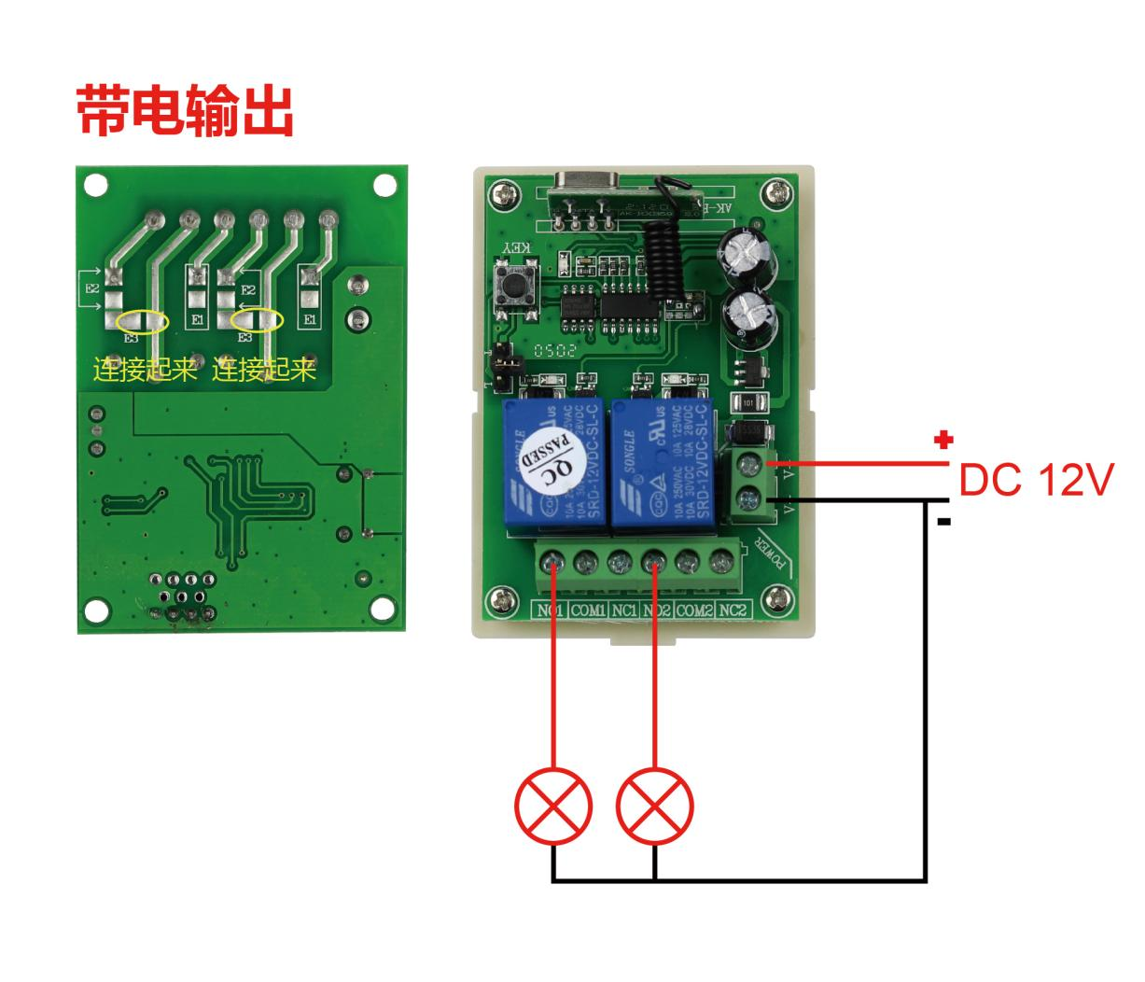

Notes
- The operating voltage must not exceed the rated voltage.
- Keep out of reach of children.
- In environments with significant wireless interference, the control distance may be reduced.
- Do not use in humid environments, as this may damage the controller.

Edit History
Version | Update date | Update content | write | Review | Approval
V2.0 | 2021-6-23 | Document distribution | Cai Dajun | Cai Weijie

